Baseline Evaluation of XAFS Bending Magnet Beamlines
Experiments performed under “standard optimized operating conditions,” as recorded.

Steve Heald
Matt Newville
Mali Balasubramanian
Julie Cross

- Rhodium coated harmonic rejection mirror, angle varies. See notes for specific test.
- The SRS-570 current amplifier gain settings are recorded in the data file headers.
- A 10% DC offset on the SRS-570 was automatically corrected by the data acquisition software.
- The monochromator was detuned by 10% on the preslit detector.
- Feedback stabilization was not used, although it is available.
- The beam was unfocused, although vertical focusing is possible with the 20-BM HR Mirror.
- Dry N₂ flowing in I0[15 cm] and IT[30 cm] ionization chambers.
- Chambers operating at 600 VDC, except where noted.
- 7 GeV electron synchrotron operating in top-up mode, 100 mA (nominal).
- I0 entrance slits 1.1 mm vertical x 10 mm horizontal.

N.B. Sector 21 is under construction, so this is probably a worst-case-scenario for noise (audible noise—ugh!!).
ENERGY CALIBRATION: Experiment log

XANES scans of metal foil reference standards collected over a large energy range without recalibrating the monochromator.
- Metal foils from EXAFS Company (Joe Wong). Set provided by M. Newville.
- For the low energy range (V, Cr, Cu and Zn ), harmonic rejection mirror set to 5 mrad.
- Cutoff ca. 13,400 eV.
- All XANES collected at 0.2 sec/point, unless otherwise noted.
file name | foil | edge energy |  | step size
file name | foil | nominal† | measured‡ | step size
cufoil.0001 | Cu | 8980.48(2) | 8980.1 | 0.4 eV
znfoil.0001 | Zn | 9660.76(3) | 9660.8 | 0.4
crfoil.0001 | Cr | 5989.02(4) | 5988.91 | 0.3
vfoil.0001 | V | 5463.76(5) | 5464.04 | 0.3
Changed beamline settings to work at the high energy range. Changeover took about 1/2 hour, not including detector gas equilibration time.
- For the high energy range (Mo, Ag), harmonic rejection mirror set to 2.3 mrad.
- Cutoff ca. 29,130 eV.
- I0 entrance slits reduced to 0.8 vertical x 10 mm horizontal.
- Switch to Ar in I0[15 cm] and IT[30 cm] at 600 VDC for Mo and Ag XANES.
- Detector gases allowed to equilibrate while we all go for lunch, coffee, etc. around 12:45.
file name | foil | edge energy |  | step size
file name | foil | nominal† | measured‡ | step size
mofoil.0001 | Mo | 20,000.36(2) | 20,001.9 | 0.8 eV
agfoil.0001 | Ag | 25,515.6(3) | noisy, split peak | 0.8 eV
We see a double peak in the 1st derivative of agfoil.0001, and assume it is noise.
- Increase counting time to 0.5 sec/point.
file name | foil | edge energy |  | step size
file name | foil | nominal† | measured‡ | step size
agfoil.0002 | Ag | same | 25,521§ | 0.8 eV

†Rev. Sci. Instrum., 67 (1996) 686.
‡Using first peak in first derivative of XANES scan taken at the beamline with LabView DAC.
§May need to apply a smoothing algorithm to the Ag XANES to get a decent derivative.

ENERGY CALIBRATION: V K data (Athena screen shots)

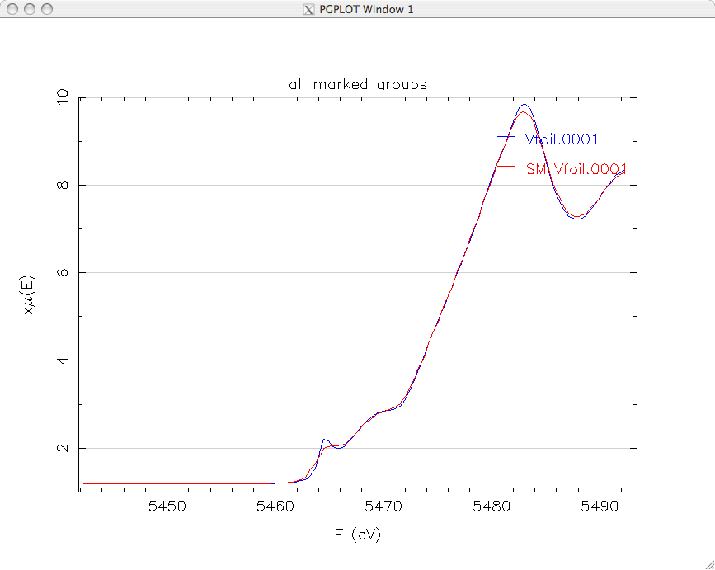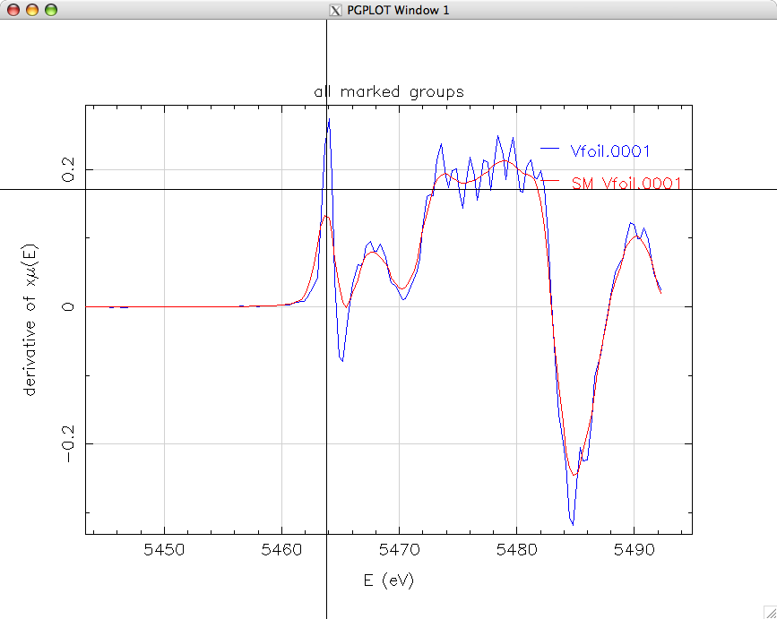
ENERGY CALIBRATION: Cr K data

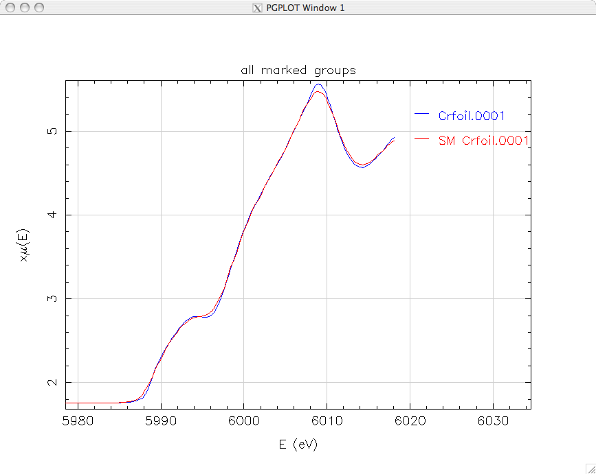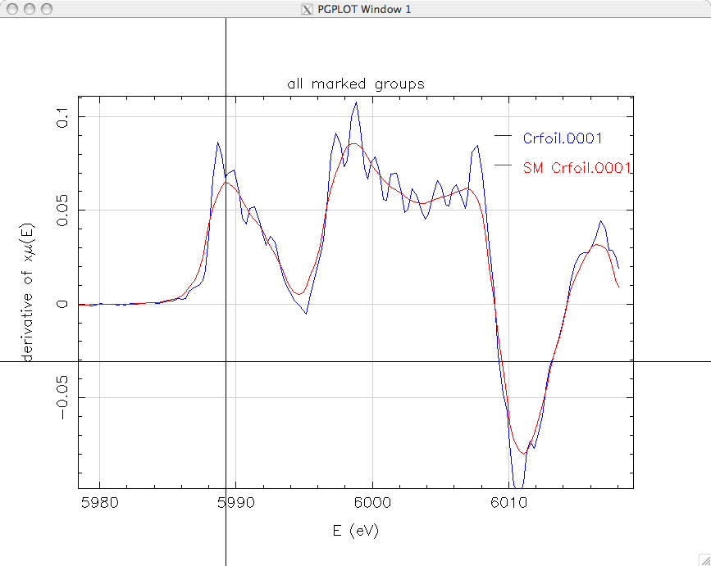
ENERGY CALIBRATION: Cu K data

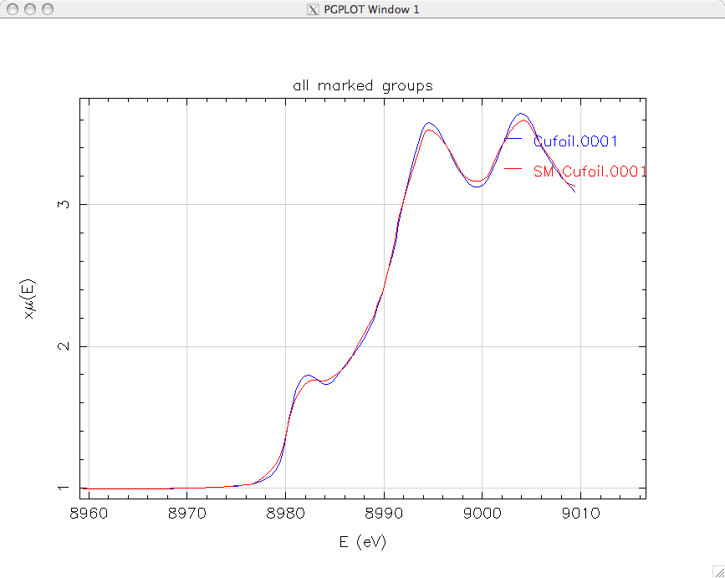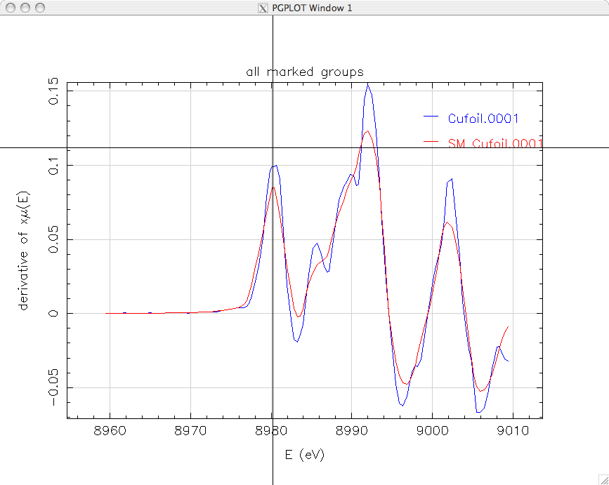
ENERGY CALIBRATION: Zn K data

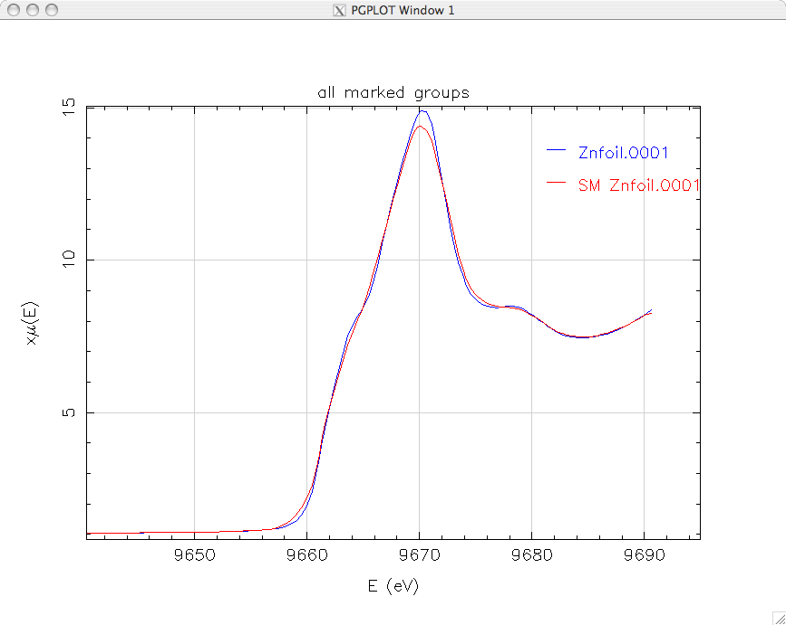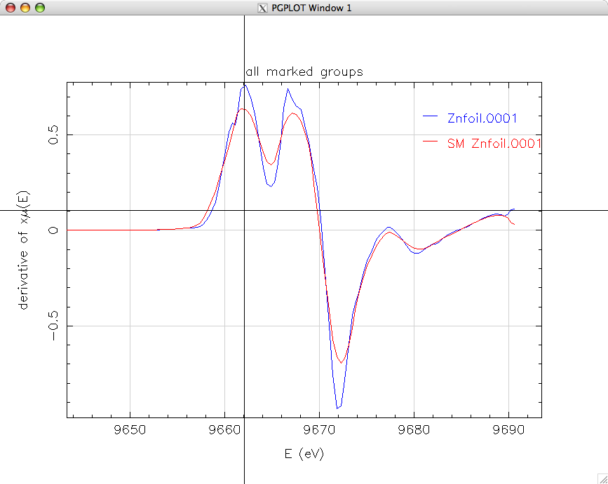
ENERGY CALIBRATION: Mo K data

From Steve Heald
ENERGY CALIBRATION: Ag K data

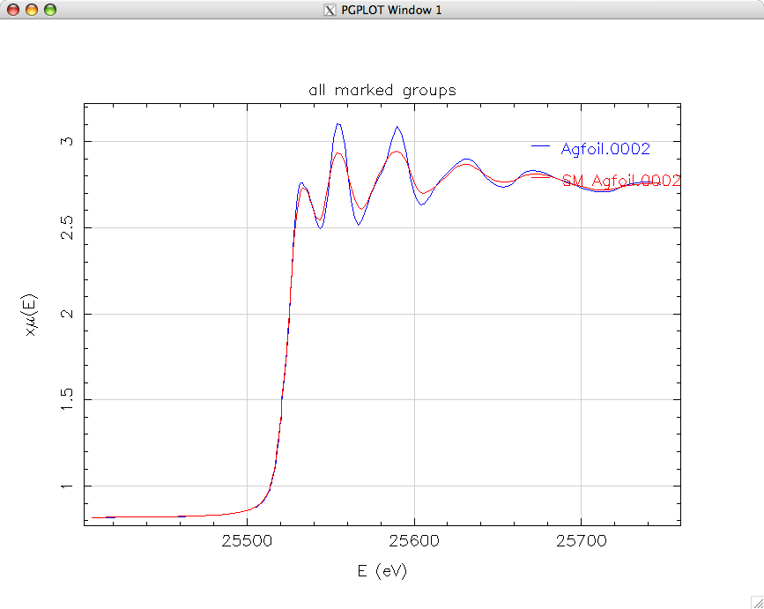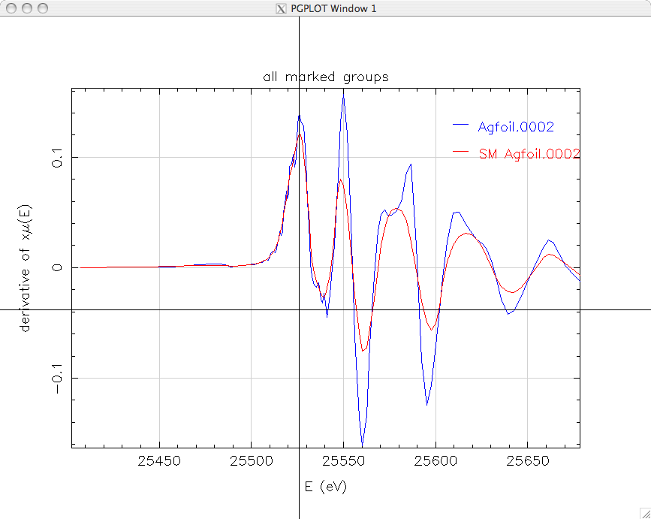
ENERGY CALIBRATION: Results

file name | foil | edge energy
file name | foil | nominal† | measured‡ | difference
vfoil.0001 | V | 5463.76(5) | 5463.82 | 0.06
crfoil.0001 | Cr | 5989.02(4) | 5989.49 | 0.47
cufoil.0001 | Cu | 8980.48(2) | 8980.21 | -0.21
znfoil.0001 | Zn | 9660.76(3) | 9662.02 | 1.26
mofoil.0001§ | Mo | 20,000.36(2) | 20002.05 | 1.69
agfoil.0002§ | Ag | 25,515.6(3) | 25526.35 | 0.75

†Rev. Sci. Instrum., 67 (1996) 686.
‡Using first peak in first derivative of XANES scan, after application of Athena smoothing algorithm, with the exception of the Mo XANES, which was processed using a spline smoothing algorithm.
§High energy edges measured with Ar in I0 and IT; detectors gases equilibrated ca. 1 hour, over lunch break.
ENERGY RESOLUTION: Experiment log

Measure the full width at half maximum of the V₂O₅ pre-edge feature.
- The sample is powder-on-tape prepared by Matt Newville.
- Harmonic Rejection Mirror set to 6 mRad.
- cutoff of ca. 11,179 eV.
- Scan details: pre-edge –100 to –20 eV, Post-edge 30 eV to 8k (240 eV) for accurate normalization.
filename | slit size |  | FWHM of feature | step size
filename | V | H | FWHM of feature | step size
V2O5.0002 | 1.1 mm | 6 mm |  | 0.2 eV
V205.0003 | 600 µm | 6 mm | 1.865 +/- 0.018 eV | 0.2 eV

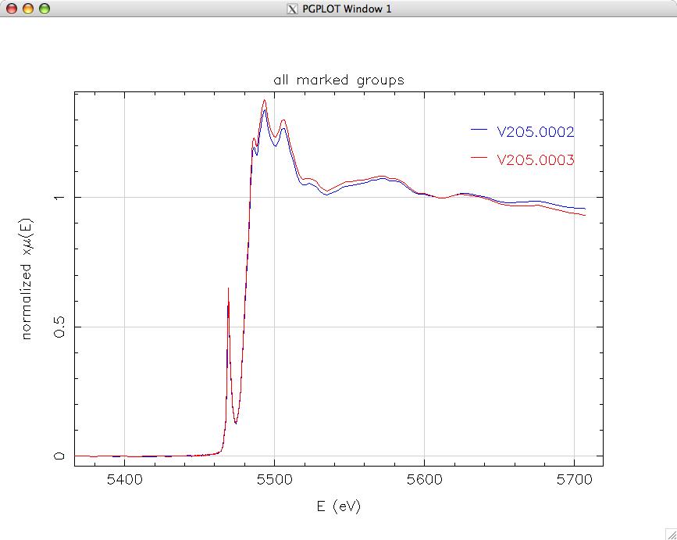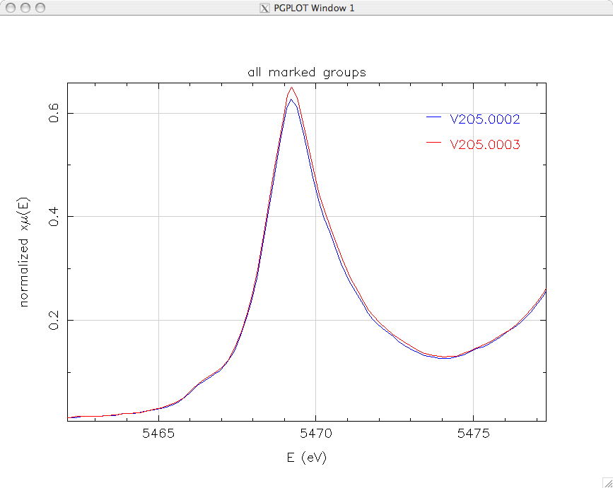
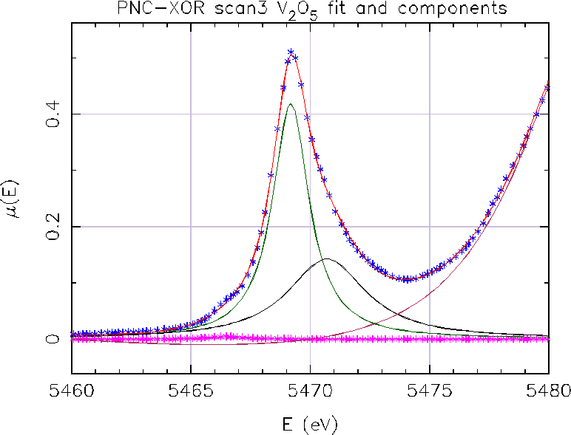From Matt Newville

HARMONIC CONTENT: Experiment log

Scan the energy around 6.66 keV through a Mo foil to look for emergent Mo XANES from the third harmonic.
- Nominal edge position for Mo is 20,000 eV. Run a XANES scan with E0 = 6,6667.
- Harmonic rejection mirror set to 8.5 mRad.
- nominal cutoff ca. 7880 eV.
- Limiting factor in HR cutoff is tilting the BM table. N₂ in both chambers.
- I0 is 15 cm, IT is 30 cm gas ionization at 600 VDC.
- 25 µm thick Mo foil from the PNC set of foil standards.
filename | IT | I0 | v/f counts | sec/pt
moharmonic.0001 | 20 pA/v | 10 nA/V |  | 0.2
moharmonic.0002 | same | same | 100 (basically noise) | 1.0
monochromator fully tuned, rejection only by HR mirror
moharmonic.0003 | same | same | 800 | 1.0
†Crude estimate at beamline is 2-3 x 10^4 harmonic photons/sec.
‡Crude estimate at beamline is 10^3 harmonic photons/sec.

BASE NOISE LEVEL: Experiment Log

Record at 10 keV for 3 minutes. Record with beam off for 3 minutes. Record data with knife edge 1/2 way through beam, Horizontal and Vertical, for 3 minutes.
- Harmonic rejection mirror set to 5 mRad. on the HR mirror.
- Return to standard optimized settings:
  - Monochromator detuned by 10% on pre-slit detector.
  - Re-centered I0 slits.
  - Slit size H x R = 6 mm x 1.1 mm (est.)
Dummy scan for 3 minutes at 1 sec/pt (180 points). Estimated run time for scan is 3 min. 18 seconds. Measure offsets. Gains are I0 20 nA/V; IT 10 nA/V.
filename | condition | p-p on µ | topoff event
beam_noise.0001 | 10 keV | 2 x 10^-4 | 0.5%
beam_noise.0002 | beam off
beam_noise.0003 | 1/2 blocked Vert.
We took the harmonic rejection mirror back to zero angle to double check the angle calibration. The mirror not have been correctly aligned for the previous measurements, and we may want to repeat HARMONIC CONTENT evaluation.

BREAK FOR LUNCH 12:43.
Construction noise seemed to settle down around 3pm. At least most of the grinding, drilling, and hammering has stopped.

DATA QUALITY: Experiment log

Transmission EXAFS of solutions with 0.1 edge step in ca. 2 absorption lengths of water. Cover a range of energies (Cl, Zn, Cd).
Solutions and transmission cells prepared by Matt Newville using dilution calculations by Bruce Ravel.
zinc nitrate
445 mg Zn(NO₃)2•6H₂O (Alfa #22403)
was dissolved into ≈40 ml H₂O (Fischer W2-4 DIVF water) and stirred for 5 minutes.
The solution was then brought to 50 ml.
cadmium nitrate
626 mg Cd(NO₃)2•6H₂O (Alfa #21853)
was dissolved in ≈25 ml H₂O (Fischer W2-4 DIVF water) and stirred for 5 minutes.
The solution was then brought to 30 ml.
Beamline 10% detuned on pre-slit; HR mirror at 5 mRad; N2 in I0 (15 cm) and IT (30 cm) at 600 VDC.
filename |  | slit size | edge step height
znsolution.0001 | 0.2 sec/pt | 1.1 mm x 6 mm | 0.12
znsolution.0002 | 1 sec/pt | 1.1 mm x 10 mm |  | ca. 10^-3 noise
znsolution.0003 | repeat | repeat
Beamline Ar in I0 (15 cm) and IT (30 cm) at 600 VDC; HR mirror to 2.3 mRad; close slits to 800 µm x 10,000 µm; beam height changed with large energy change (from 10 keV to 20 keV); The flux seems too low, so SH takes the HR mirror back to zero angle and adjusts height to center in beam. It was off by 800 µm, which is the same as the entrance slit height, so this error had a huge effect on the flux. Nominal Cd edge position is 26,713 eV.
I0 | IT
50 nA/V | 50 nA/V
EXAFS scan parameters saved as JPEG.
filename |  | slit size | edge step height
cdsolution.0002 | 1 sec/pt | 0.8 mm x 10 mm | 0.14
cdsolution.0003 | repeat | repeat
Cd and Zn have comparable flux, noise, and reproducibiliby.
(6) FLUX at 10 keV: Measure on all beamlines with a common detector/amplifier combination.
ADC 10 cm detector, 1000 VDC, N2 stp, slit size is 1 x 10 mm, 4.1% absorption
detuning |  | HR mirror | gain | current | flux†
10% | 1000 VDC | 5 mRad | 10 nA/V | 2.309 V (offset corrected) | 1.1e10
same | 500 VDC | same | same | 2.296 V
†calculated using PNC web programs

DETECTOR LINEARITY: Experiment Log

Move a knife edge or aperture across the incident beam and monitor the I0/IT ratio.
Apparently there are several different types of linearity tests one could perform. We debate the merits and applicability, and decide to perform a slit scan: scan a narrow slit across the beam horizontally, to see how uniform the detector is from side to side.
filename | beam size |  | IO | IT | comments
filename | H | V | IO | IT | comments
HSlitScan.0003 | 1 mm | 1 mm | 2 nA/V | 2 nA/V | check uniformity of the ionization chambers from side to side
attenuatorscan.0001 | 1 mm | 10 mm | 20 nA/V | 20 nA/V | Also used IRef at 10 nA/V. Dummy scan, with manually inserted layers of 12.5 µm Mo foil
Monochromator detuned 10% on pre-slit; HR mirror at 5 mRad; N2 in I0[15 cm] and IT[30 cm]

BEAMLINE OPERATIONS

Practical limits on energy range for EXAFS (highest and lowest measured spectra)
Chlorine, but requires major modifications to “standard” configuration to reduce attenuation.
Ease of changing energy
Large energy changes, such as from 10 keV (Zn) to 25 keV (Cd) required some manual adjustment of the optics, including the HR mirror zero, HR mirror tilt (normal, since cutoff energy is different), detuning, slit size (to match HR mirror acceptance), gains, detector gases.
Availability of detectors
<comment>
Availability of special sample environments (high/low temp., vacuum, pressure, etc.)
<comment>
Ease of integrating APS Pool Detectors and Equipment
<comment>
Data collection software
<comment>
On-line data processing and analysis
<comment>
Sources of systematic errors (random electronic noise, known monochromator glitches, etc.)
<comment>

SOFTWARE CAPABILITIES (need to make a table for this)

maximum number of regions for energy scans
k-space scanning
k-weighted integration time
automatic offset correction
macro capabilities
plotting capabilities
on-line analysis capabilities
example of data file header (what information is automatically recorded)

9.1 % absorption at Cd, 15 cm Ar. estimated flux is 8x10^9 above the edge.

