Evaluation of noise level in Zn solution XAFS data: 20 BM

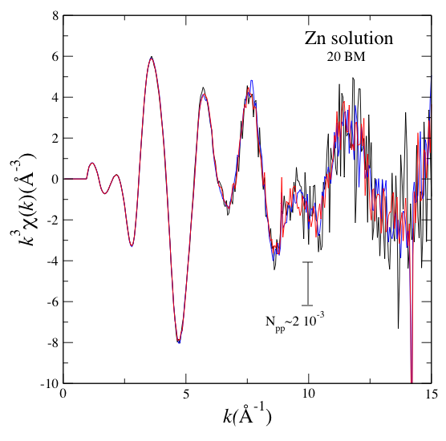

The noise level was estimated in a couple of ways. First the peak-to-peak noise was estimated directly from the edge-jump normalized data, by weighting the XAFS with w=3. The peak-to-peak noise level is estimated at about N_{pp}~2 10⁻³ (I used the scan-to-scan variation at k ≈ 10 inverse Angstroms so the y-scale needs to be divided by 10^3=1000).

Then the scan-to-scan rms variation in the data was calculated for each k-point by simply calculating the standard rms:

$${\bar{N}}_{\text{rms}}(i)=\sqrt{\frac{\sum_{j}^{\text{scans}}{[c_{j}}(i)−\bar{c}(i)]^{2}}{\text{scans}}}$$

which is then averaged over all data points to obtain an averaged rms:

$${\bar{N}}_{\text{rms}}=\frac{\sum_{i=1}^{\text{po}\text{int}s}{{\bar{N}}_{\text{rms}}(i)}}{\text{po}\text{int}s}$$

This numerical estimate yields 7.8 10⁻⁴. How do the numerical estimate and the eye-balling estimate from Fig. 1 compare? We need to remember that N_{rms}=0.707N_{peak}, and that N_{pp}=2N_{peak} so the N_{rms}=N_{pp}/2.828. Using the values from Fig. 1 we obtained that the eye-balled N_{rms}=2 10⁻³/2.83=7.1 10⁻⁴, which is essentially what we obtained numerically.

This exercise tells us that we can trust the estimate of the noise level. Now the question is how good or bad it is. We would like to compare it with the expected noise form counting statistics. For that, we need to know the total number of photons (photons not counts!) in the absorption edge jump- since the XAFS is normalized to the edge jump.

I looked at the number of counts in the transmission chamber below and above the edge. The total number of counts is approx. 18260 below and 16600 above. That means the number of “counts absorbed” are 1600. The SRS current-to-voltage amplifier was set at a gain of 10 na/V and the voltage to frequency converter was set at a gain of 20 V/MHz (this means that 1 volt gives 50,000 counts in your scaler). The 1600 counts correspond to 0.032 volts (32 mV) signal in the ion chamber. And this corresponds to 0.32 nA current. You can use all this to get a number of photons if you know the length of your chamber (30 cm) and the gas (Nitrogen)) and the # of electron hole pairs created by 1 photon (?). I don’t. So I used an IDL routine that is part of XOP that calculate the conversion factor from counts to photons given the amplifier gain, the gas in the chamber, its length and the V→f gain. I got the conversion factor for the number of incoming photons (into the ion chamber) to be approx 330000. So 1600*330000=5.28 10⁸ photons in the transmission jump. So photon counting statistics tells us that we expect N_{rms}=4.3 10⁻⁵. The data has noise levels approx 16.5 times larger than counting statistics.

I would encourage you to check my math and try to reproduce these numbers. Since we need to compare noise levels between the different beamlines, I suggest that we use as a ruler not the actual noise in the data- but the ratio between measured rms noise and expected counting statistical noise. If I didn’t make mistakes here (very unlikely) that ratio for this measurement at 20 BM is approx 16.5 .

